Japanning Study/Training Day Report
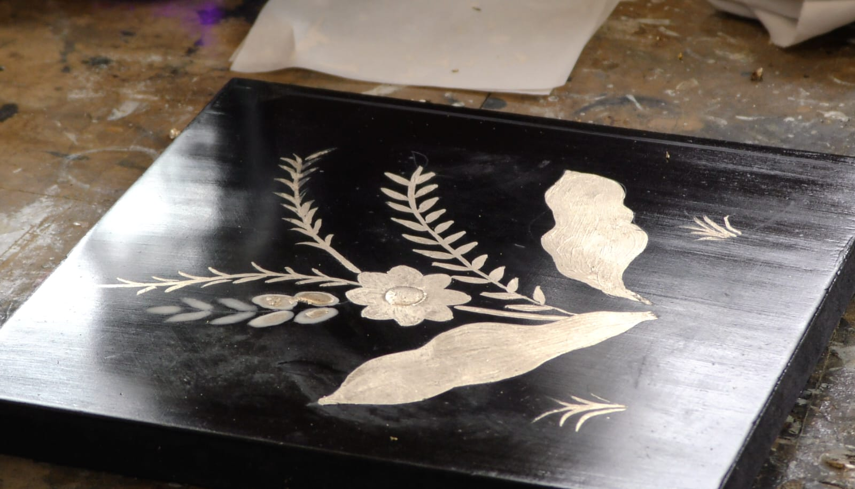
Members, students and guests recently gathered at BAFRA Accredited Member, Rod Titian’s, studio for a most enjoyable day of Japanning. The Titian Studio is one of Europe’s premier restoration and conservation workshops and leading exponent of European Japanning, so there was no better setting for our latest study day.
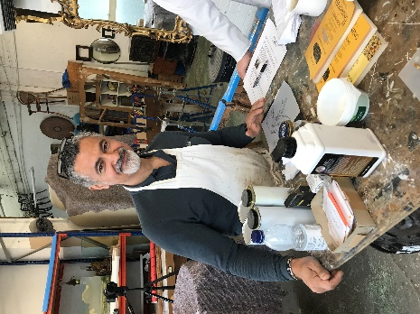
Rod, our host, started by outlining the history and techniques of Japanning. He told how merchants brought back examples of the ancient oriental craft of applying Urushi lacquer, gold and other materials to a wide range of objects. During the 17th and early 18th centuries demand for lacquered goods began to outstrip supply and the work became much imitated in Europe. Various methods of ‘Japanning’ (replicating the designs and techniques of the Far East) were developed in Britain, France, Italy, Scandinavia and elsewhere in Europe. Each with their own take on the art, using materials and techniques they knew and understood, rather than using Urushi lacquer which often proved toxic to Europeans.
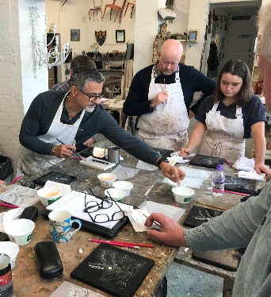
Delegates then learnt of how to build up the groundwork and the materials to use, when conserving or restoring Japanned items. Most delegates were familiar with many of the materials, such as gesso, shellac and pigments and their application. Having discussed the various aspects of this, the focus turned to the practical exercise of the day, the decoration of the groundwork.

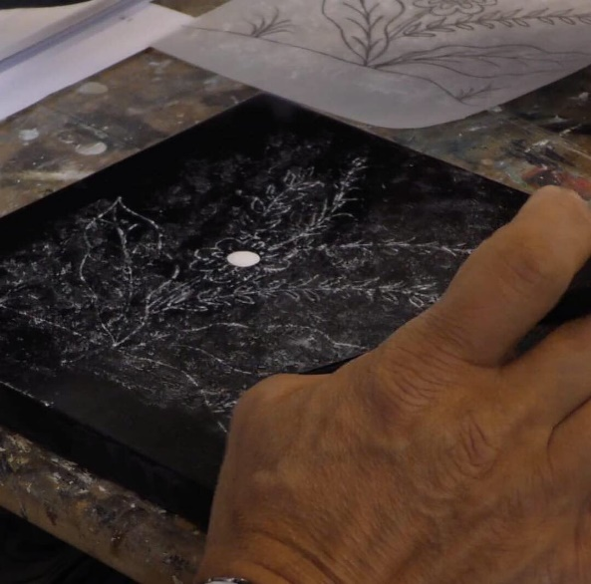
Each delegate was presented with a board, prepared with a black groundwork and small raised area that was ready for decoration. A simple flower design was to be used, but the skills and techniques used would be applicable to any number of designs, perhaps replicating something that might feature on an item for conservation or restoration. Rod then proceeded to demonstrate each stage in the process. As he worked, he described his actions, talking through the techniques and how to achieve the best results. This even included tips on how to hold the brush and work across the design. Invaluable instructions, that are difficult to pick up from a book, perhaps. Before each stage, Rod discussed the materials and their properties, how to use them and what to use for different applications.
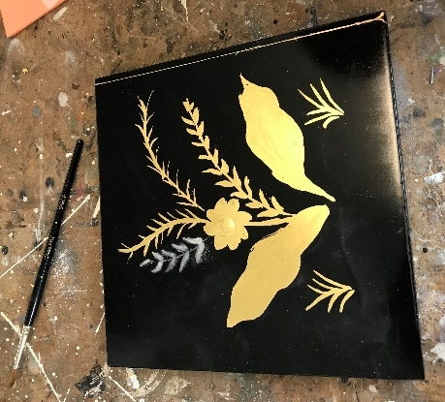
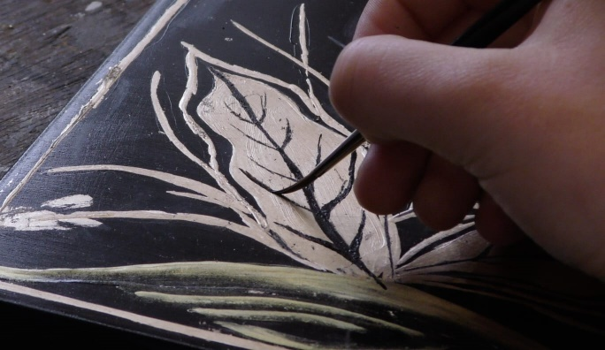
After the demonstration of every stage, each delegate then had the opportunity to practice what they had learned and try it for themselves.

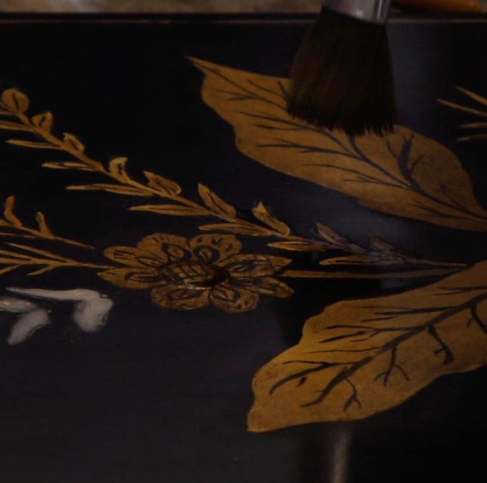
Easier said than done, Rod having made it all look so easy and straightforward, as you would expect from a master. Delegates learnt how to build up raised areas with gesso, transfer a design, choose a size and apply it, gild using various types of gold leaf and powder, clean up the design, paint in fine details and finally distress and age the panel. They also became acquainted with all the tools, brushes and materials to achieve the desired result.
As delegates worked, silence fell, such were the levels of concentration! Having said that there was much conversation in between stages and over lunch comparing each other’s handiwork and catching up with old friends.

At the end of the day, the boards were displayed and what a fine sight they made - the same design, yet different and individual. A very satisfying end to the day.

Many thanks to Rod at Titian Studios and those who attended for making the Japanning Study Day such an interesting and enjoyable experience.
